**Energy Efficiency of WSN**

In recent years, wireless sensor networks has been greatly developed, but power consumption is still an important factor restricting the development of wireless sensor networks, wireless sensor nodes. Since the small size of sensor nodes, portable battery power is limited, the sensor node is discarded and failure due to the limitation of energy, therefore the energy supply constraints are obstacles sensor network applications [1]. In addition, the number of multi-sensor nodes, low cost requirements, wide distribution area, and regional environmental complex deployments, some regions even personnel are unavailable, the sensor node by way of replacing the battery to supplement energy is unrealistic. The above two points makes the application of sensor networks has been greatly restricted. If the primary design goals of traditional wireless network is to provide high quality of service and efficient bandwidth utilization, followed before considering energy saving, then, the primary design goals sensor network is efficient use of energy, and how to maximize the efficient use of energy is a sensor network life cycle the primary challenge facing the network, which is one of the most important differences between sensor networks and traditional networks.

The energy consumption of different parts of sensor nodes is somewhat different.

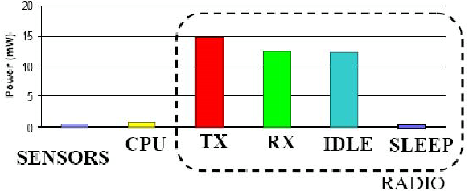

Figure 1. The energy consumption of different parts of WSN

The figure above shows the different energy consumption of different parts of WSN. Although different nodes on the respective power values are vary, but for most sensor nodes, power distribution is consistent with the general characteristics: firstly, the power consumption of sensor unit and the processor unit is far less than the energy consumption of the communication unit; secondly communication unit transmits data, the most of energy consumes when data is received and the unit is sleep, and the energy consumption is much smaller when the communication unit power consumption in sleep mode.

For the characteristics above, the methods of energy-saving for wireless sensor networks can be divided into two parts: hardware and software. The hardware schemes are mainly includes the efficient use of batteries, reduce energy consumption when the sensor is working, energy harvesting technology. For the main methods of software, there are protocol stack, cross-layer optimization, topology control algorithms and so on.

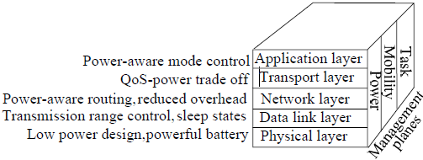

Figure 2. Wireless sensor network protocol stack

Currently, there are a number of ways from each layer of the sensor node protocol stack.

At the physical layer, the use of low-power devices and turn off unnecessary transaction performance can save a lot of energy. The energy consumption of the radio transceiver can be reduced by reducing the transmitting time. According to the instantaneous load flow, dynamic use of different modulation schemes can save energy. Determining the energy consumed on each node, identify the factors affecting the energy consumption of different components. Factors include the sensing element signal samples consumed, power, signal conditioning physical signal conversion, analog-to-digital converter (ADC).

Foe the data link layer, which is includes MAC and error control protocol. Since transport consumes most energy in the sensor nodes, the protocol of MAC should reduce the minimum energy efficiency of access to save the energy.

At the network layer, according to the versatility of the different nodes of the network may take directional, multi-hop, hop single cluster, or multi-hop clustering transmission scheme.

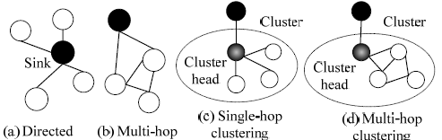

Figure 3. Different transmission schemes in WSN

And routing protocol is the protocol to find the most energy-efficient route without increasing latency.

**Classification of Wireless Sensor Network routing protocol**

WSNs routing protocol is responsible for the reliable transmission of data between the sink nodes and the remaining nodes. Since WSNs highly correlated with the application, a single routing protocol cannot meet the needs of a variety of applications, which have been studied numerous routing protocols. In order to reveal the characteristics of the agreement, a variety of classification methods can be used to classify them, such as communication mode, routing protocol, the route structure, establishment of timing routes, state maintenance, node identification strategies and delivery methods, using a variety of classification methods classify them [2][3]. Because the researchers combine multiple strategies to achieve routing mechanism, it belongs to the same routing protocols can be divided into different categories.

1. According to how many paths are used during transmission path can be divided into single-path routing protocol and multi-path routing protocol. For single-path routing, which can save storage space and the amount of communication data are less. For multipath routing, which is fault-tolerant, robust good, and an optimal route can be selected from the numerous routes.
2. According to whether there is a hierarchy node in the routing process, it can be divided into flat and hierarchical routing protocols. Plane routing is simple, robust good, but the cost of establishing and maintaining is high, and the number of hops of data transmission is more. So it is more suitable for small-scale network. Hierarchical routing scalability for large size of the network, but the cost of cluster maintenance is much, and the cluster head node is the key route, whose failure would cause routing fail.
3. According to the relationship between the timing of the data transmission route established and data transmission, routing protocols can be divided into active, on-demand routing protocol and hybrid routing protocol. The cost of active routing is overhead and resource requirements are high; the delay of demand routing is large.
4. Depending on whether the geographical position is used to identify the destination and the route calculation, it can be divided into location-based routing protocol and non-location-based routing protocols. There are a lot of WSNs applications need to know the location of the incident, but it requires a GPS positioning system, or other targeting methods to assist node computes position information.
5. According to consider whether there is QoS routing constraints, it can be divided into guaranteed QoS routing protocol and does not guarantee QoS routing protocol. QoS guaranteed routing protocol refers to consider QoS parameters, such as delay, packet loss rate when a routing is establishes.
6. According to whether the data aggregation process during transmission, it can be divided into data aggregation routing protocol and non-data aggregation routing protocol. Aggregation routing protocol can reduce the traffic, but it takes time synchronization technology support, and increase the transmission delay.

**Analysis of Routing Protocol in WSN**

1. Flooding Protocol and Gossiping Protocol. These two protocols are the most classical and traditional protocols in WSN. In flooding protocol, nodes broadcasts to all neighbor nodes when they are transmitting or receiving data, and the broadcast stopping when the data arriving the destination. Flooding is very simple to implement, because it does not maintain any routing table and does not require discovering any routes. But this technique has several disadvantages, such as it is responsible for large bandwidth consumption and it wastes valuable energy. This is not an energy aware protocol. Gossiping protocol is the improved flooding protocol, it avoiding implosion but increase the delay.
2. SPIN Protocol. This is the first protocol based on data routing. When the node generates or receives data, in order to avoid the spread of the blind, it will transmit a notice to neighbors with ADV message, and the node that need the data will send REQ message as request, the data is sent to the requesting node as DATA message. The advantage of this protocol is: small ADV message alleviate the implosion problem; by naming data to solve the overlap problem; avoiding the use of resources blindly. Comparing with Flooding and Gossiping protocol, this protocol effectively saving energy, but the drawback is: when all neighbors do not need this data, the data will not be forwarded, which will cause distant nodes can not get the data, when most of the network node is a potential sink points, the problem is not serious, but if there are less sink point, it is a very serious problem; and when a sink point request every data, its surrounding nodes will run out of energy easily.

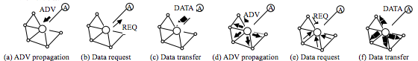

Figure 3. Routing setup and data transmission in SPIN protocol

1. LEACH and DEEC protocol.

LEACH protocol is the first data fusion hierarchical routing protocol. To balance the energy consumption of each node, the heading node is selected randomly by round. Nodes creates a random number between 0 and 1, and if the number less than T(n), the node will be the heading cluster.

$$T\left(n\right)=\left\{\begin{matrix}\frac{p}{1-p×\left(rmod\frac{1}{p}\right)} \\ 0, else\end{matrix}\right., n∈G$$

Where p is the percentage of the number of cluster and the number of nodes, r is the number of rounds and G is the set of nodes that are not heading of cluster in recent 1/p round.

The heading cluster will broadcast this message via the radio channel, and the remaining nodes choose to join the cluster that has the strongest signal cluster header. Node will delivery the data to cluster head by a single hop, and cluster head also send the aggregated data to sink point by one hop. This protocol uses random cluster head selection to avoid excessive consumption of energy cluster heads, and increases network lifetime; data aggregation can effectively reduce the level of traffic. In this protocol, transmission delay is small, but it requires a higher level of power. Even in small-scale networks, nodes farther away from the sink point will use high-power communications, and it will lead to a shorter life time.

DEEC protocol is a improved LEACH protocol, the only different of these two protocols is, DEEC will chose the node with higher rest energy as the cluster head [4].



Figure 4. Performance of LEACH and DEEC

The figure above shows the performance of two different protocols in WSN. The life time of DEEC is longer than LEACH. And the longer life time means less energy consumption.

**MIMO technique in WSN**

Multiple-Input and Multiple-Output (MIMO), is a kind of smart antenna technology, which uses multiple antennas at both transmitter and receiver to optimize the performance of communication systems. In this case, the data throughput and link range increase significantly compared with original technology. Furthermore, MIMO do not need to raise the power of transmitter or channel bandwidth, it divided integral transmit power into multiple antennas to achieve array gain and diversity gain that improves the spectral and the link reliability respectively.

This energy efficiency investigation of MIMO scheme is broadened to individual single antenna nodes that collaborate to form multiple antenna transmitters or receivers [5].



The figure above shows the total energy consumption of WSN with and without use MIMO. MIMO can reduce the total energy consumption when the distance is long.

References

[1] Sun Limin,Li Jianzhong,Chen Yu,Zhu Hongsong, “Wireless Sensor Network[M]”. Peking: Tsinghua University Press, 2005.

[2] Haas ZJ, Halpern JY, Li L. “Gossip-Based ad hoc routing”*, IEEE Communications Society*, 2002, pp. 1707−1716.

[3] Kulik J, Heinzelman WR, Balakrishnan H, “Negotiation based protocols for disseminating information in wireless sensor networks”, *Wireless Networks,* Vol. 8, No. 2, pp. 169−185.

[4] S. Tripti, B. Kumar & G.S.Tomar, “Performance Comparision of LEACH, SEP and DEEC Protocol in Wireless Sensor Network”, *Proc. of the Intl. Conf. on Advances in Computer Science and Electronics Engineering,* pp. 10-17.

[5] V. K. Sachan & S. A. Imam, “Performance Analysis of Cooperative MIMO Techniques in Wireless Sensor Networks”, *Journal of Telecommunications,* pp. 32-41.